A PROJECT REPORT

## "IOT BASED SOCIETY AUTOMATION USING GTBS PROTOCOL”

### UNDER THE GUIDANCE OF

PROF.AYUB MULANI

**SUBMITTED BY**

GADADE VINAY

TANUJA JAWALE

MHETRE SUCHITRA

SARGAM KRUSHNACHAITANYA

### IN PARTIAL FULFILLMENT OF THE REQUIREMENTS FOR THE DEGREE OF

**BACHELOR OF ENGINEERRING**

### DEPARTMENT OF

ELECTRONICS AND TELECOMMUNICATION ENGINEERRING

**SHALAKAFOUNDATION**

### KEYSTONE SCHOOL OF ENGINEERRING (2021-2022)



**SHALAKA FOUNDATION’S**

**KEYSTONE SCHOOL OF ENGINEERING**

### CERTIFICATE

**This is to certify that Project completed**

### "IOT BASED SOCIETY AUTOMATION USING GTBS PROTOCOL”

**SUBMITTED BY**

GADADE VINAY

TANUJA JAWALE

MHETRE SUCHITRA

SARGAM KRUSHNACHAITANYA

Is a record of the bonafide work carried out under the supervision of Prof. Ayub Mulani and is approved as the complete fulfillment of the requirement for the award of degree in Electronics and telecommunication engineering of the University of Pune.

|  |  |  |
| --- | --- | --- |
| **Prof. A. Mulani** | **Prof.R.A.Barapate** | **Principe** |
| **Guide** | **Head of Department** |  |
| **Department of E&TC** | **Department of E&TC** |  |

#### Place:PuneDate:

**ABSTRACT**

Society automation is becoming popular due to its numerous benefits. Home automation refers to the control of home appliances and domestic features by local networking or by remote control. Artificial Intelligence provides us the framework to go real-time decision and automation for Internet of Things (IoT).The work deals with discussion about different intelligent home automation systems and technologies from a various features standpoint. The work focuses on concept of society automation where the monitoring and control operations are facilitating through smart devices installed in residential buildings. Heterogeneous society automation systems and technologies considered in review with central controller based, email based, Bluetooth-based, mobile-based, SMS based, ZigBee based, Dual Tone Multi Frequency-based, cloud-based and the Internet with performance.

Automation is a technique, method, or system of operating or controlling a process by electronic devices with reducing human involvement to a minimum. The fundamental of building an automation system for an office or home is increasing day-by-day with numerous benefits. Industrialist and researchers are working to build efficient and affordability automatic systems to monitor and control different machines like lights, fans, AC based on the requirement. Automation makes not only an efficient but also an economical use of the electricity and water and reduces much of the wastage. IoT grant to people and things to be connected Any-time, anyplace, with anyone, ideally using any network and any service. Automation is another important application of IoT technologies. It is the monitoring of the energy consumption and the Controlling the environment in buildings, schools, offices and museums by using different types of sensors and actuators that control lights, temperature, and humidity.

Wireless sensor network is thriving information collecting and processing Technology, which is widely used in military field, industry and environmental monitoring. The focus of this project is on the integration of radio frequency identification (RFID) and Wireless sensor network (WSN) in smart homes and applications of this system such as identifying a caregiver who enters the home.

Keywords: -VB, GTBS, Temperature sensor, Android Application, WSN

## ACKNOWLEDGMENT

We would like to take the opportunity to express true sense of gratitude towards our project guide **Prof. Ayub Mulani** for her valuable co-operation and guidance that gave us for this project.

We would also like to thank our head of the department **Prof. R. A. Barapate** for inspiring us and providing us all facilities with internet,which helped us with the project work.

We would also like to express our appreciation and thanks to **Prof.Nazish Fatima** for her valuable Help, Time and for the co-ordination with us.

**INDEX**

|  |  |  |
| --- | --- | --- |
| Sr. No | Content | Page No |
| 1 | Introduction | 7 |
| 2 | Literature Survey | 9 |
| 3 | Problems statement & objective | 11 |
| 4 | Specifications | 13 |
| 5 | Block diagram and Description | 14 |
| 5.1 | Block diagram | 15 |
| 5.2 | Block diagram Description | 16 |
| 5.3 | Circuit Diagram | 19 |
| 6 | Software Implementation | 20 |
| 6.1 | Flow chart | 21 |
| 7 | Advantages &Applications | 22 |
| 7.1 | Advantages | 23 |
| 7.2 | Applications | 23 |
| 8 | Future Scope | 25 |
| 9 | Conclusion | 27 |
| 10 | Reference | 29 |
| 11 | Work-plan | 31 |

**1. INTRODUCTION**

* 1. **Concept**

Buildings consume almost 70% of the total electricity generated in the flat Commercial buildings account for over half of this electricity usage, and their share of energy consumption is projected to increase even further as compared to residential buildings, industry, and transportation.The Home Energy Management System is mainly composed of Smart plugs, Web server, Database and a user device.

Further more, commercial buildings are increasingly becoming mixed-use, that is, they now house both human occupants and significant energy-consuming IT equipment such as desktop computers, monitors, printers, and servers.

The Internet of Things may be an emerging topic in the industry but it’s not a new concept. In the early 2000’s, Kevin Ashton was laying the groundwork for what would become the Internet of Things (IoT) at MIT’s Auto ID lab. Ashton was one of the pioneers who conceived this notion as he searched for ways that Proctor & Gamble could improve its business by linking RFID information to the Internet. The concept was simple but powerful. If all objects in daily life were equipped with identiﬁers and wireless connectivity, these objects could be communicating with each other and be managed by computers.

RFID and sensor technology enable computers to observe, identify and understand the world—without the limitations of human-entered data .Homes of the 21st century will become more and more self-controlled and automated due to the comfort it provides, especially when employed in a private home used for security purpose. A home automation system is a means that allow users to control electric appliances of varying kind. Many existing, well-established home automation systems are based on wired communication. This does not pose a problem until the system is planned well in advance and installed during the physical construction of the building.

As we know human have used technology to make almost everything faster, easier and safer to use than ever before Internet of things is network of devices that are connected to internet that is used everyday, The Internet of Things (IOT) can be described as connecting everyday objects likes home application, sensors to the Internet In IOT the devices are intelligently linked together enabling new forms of communication between things and people, and between things themselves. The Internet of Things is a new era of intelligence computing and it’s providing a privilege to communicate around the world. The objective of IoT is Anything, Anyone, Anytime, Anyplace, Any service and Any network.

Society automation systems face four main challenges; these are high cost of ownership, inflexibility, poor manageability, and difficulty in achieving security. The main objectives of this work is to design and implement a society automation system using IoT that is capable of controlling and automating most of the house appliances through an easy manageable web interface. The proposed system has a great flexibility, by using Wi-Fi technology to interconnect its distributed sensors to home automation server. This will decrease the deployment cost and will increase the ability of upgrading, and system reconfiguration.

In below Figure shows the comparison of smart buildings in market. The graph of using smart sensors is increase day by day. As technologies changes the era of energy saving, security of flats are more so the work is done using IOT i.e. smart sensors & WIFI technology is used. So popularity of smart buildings are increases now a days.

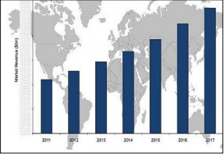

**Figure 1.1 Popularity of Smart building in market**

**2.LITERATURE SURVEY**

2.1 A REVIEW OF BASIC TECHNOLOGY

In this section, discussed different Home Automation System with their technology with features, benefit and limitations they have. “The Figure 2” shows Basic Architecture of Remote Home Automation.

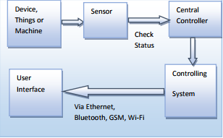

**Figure 2.1 Basic block diagram of Home automation**

* The Home automation system that uses Wi-Fi technology System consists of three main components; web server, which presents system core that controls, and monitors users’ home and hardware interface module(Arduino PCB (ready-made), Wi-Fi shield PCB, 3 input alarms PCB, and 3 output actuators PCB.), which provides appropriate interface to sensors and actuator of home automation system.
* The System is better from the scalability and flexibility point of view than the commercially available home automation systems. The User may use the same technology to login to the server web based application. .If server is connected to the internet, so remote users can access server web based application through the internet using compatible web browser.
* The application has been developed based on the android system. An interface card has been developed to assure communication between the remote user, server, RFID card and the home Appliances. The application has been installed on an android Smartphone, a web server, and a RFID card to control the shutter of windows
* PIC18F887 microcontroller for home appliances controls with GSM for control of the appliances. It has high availability, coverage and security but the cost of SMS. AT commands can be sent through the GSM network to controls the home devices.

**2.2 SOME LITERATURE SURVEY IS**

[1] British Gas Smarter living & Energy saving- It allows users to interact with home appliances and

works with a smart energy monitor that can be placed anywhere in the home. It shows the used energy, gas and electricity, as well as its cost. It is a system developed by the British Gas company and therefore it is linked to a contract.

[2]Control4Home Automation***-*** Compatible with any other smart technology. User-friendly control by a dedicated app**.**The system allows the users to control lights, audio and security in the house, but not monitoring the energy usage and production. The system must be installed professionally by an authorized dealer. It works only with internet connection and only with families of peripherals that are compatible with the controllers in this system are Bluetooth, Wi-Fi, KNX, Z-Wave and ZigBee.

[3] General Electric Brillion Technology- It allows the user to monitor and control appliances anytime, anywhere with a smart phone app. It only works with General Electric appliances; It is closed sourced.

[4]Creston Home Automation & Entertainment- The simplicity of the system and the user-friendly GUI. It is fully compatible with media players and with home automation peripherals; Customers’ service can support the users all the time. Moreover, the user manual, FAQs, email support, phone support and tutorials are available. The system allows the users to control lights, audio and security in the house, but not monitoring the energy usages and production; Many of the peripherals are specifically designed to work with Creston hardware controllers. The home automation system installation must be set by professionals. Only after the installation, the users can add compatible devices. It does not have a live chat support option or a user forum.

[5]From Buildings to Smart Buildings Sensing and Actuation to Improve Energy Efficiency- Commercial buildings consume a signiﬁcant amount of energy today and are slated to consume even more in the future. While renewable energy sources remain promising, it is expected that most of the electricity generation will still use fossil fuels in the near term. Therefore, improving the energy efficiency in commercial buildings is critical, and one of the central visions of smart building is reduce to energy. Researchers at UC Berkeley have developed a wireless meter called ACme, which uses 6LowPan to communicate, while several commercial meters exist as well.

[6] Y. Agarwal, B. Balaji, R. Gupta, J. Lyles, M. Wei, and T. Weng “Occupancy-Driven Energy Management for Smart Building Automation”. In this paper we present the design and implementation of a presence sensor platform that can be used for accurate occupancy detection at the level of individual offices. Our presence sensor is low-cost, wireless, and incrementally deployable within existing buildings.

# 3.PROBLEM STATEMENT & OBJECTIVE

## 3.1 PROBLEMSTATEMENT

The every House need safety in low maintains So implementing this IoT based smart security system by using PIC 18F452X using RFID.

## 3.2 OBJECTIVE

* To design a Wireless Sensor Network toward the implementation of intelligent building
* To design a Green task based scheduling algorithm to reduce power consumption.
* To develop a system, which can effectively monitor and control electrical appliances using IOT

**4.1 Block Diagram**

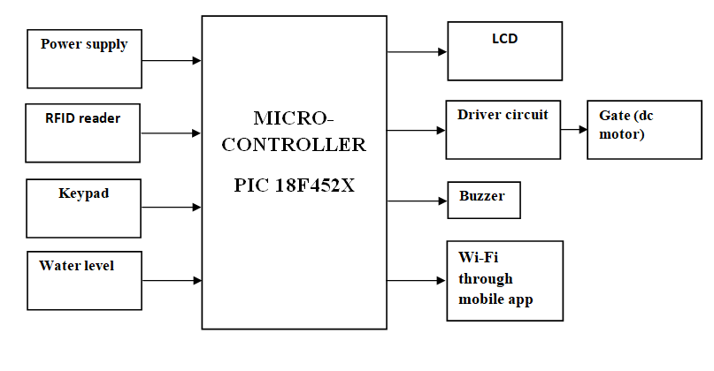

**GATE TERMINAL**

**Gate Terminal:**

In the building section we have following blocks:

RFID reader: here the user has to show the RFID tag to RFID reader. the µc reads the 10 digit RFID number and compares it with the database stored in internal memory. If password matches, access is granted, if not an indication is given to pc via RF communication.

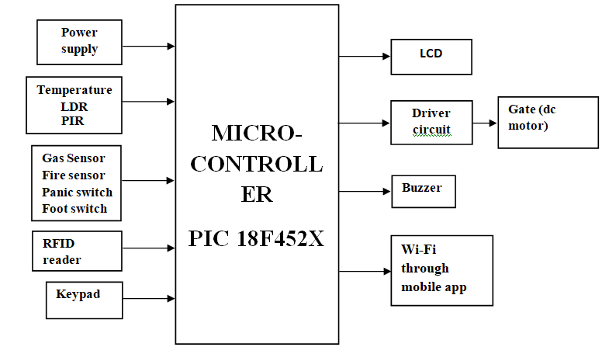

**FLAT TERMINAL**

**Flat Terminal:**

In this we have 3 Analog sensors and 4 digital sensors. We have RFID reader here also same as gate terminal.

The analog sensor is Temperature sensor, LDR and PIR.

The output of Gas Sensor, Fire sensor, Panic Switch, Foot switch are in form of digital.

**5. SPECIFICATIONS**

### 5.1Hardware

1. Micro controller (PIC)
2. Rfid reader tags
3. Lcd (16*2)
4. Motor driver circuit
5. DC motor
6. WI-FI module
7. 4*3 matrix keypad
8. Temperature Sensor: LM35
9. LPG Gas Sensor: MQ6
10. Fire Sensor
11. IR obstacle sensor
12. Light Sensor: LDR
13. RELAYS.
14. LEDS

### 5.2SoftwareRequirement

1. Embedded C
2. Proteus

**5.3 Protocols**

GTBS Protocol

**5.1 SPECIFICATIONS**

**1. PIC 18F452:**

PIC18F452 is an 8-bit with 10 MIPS, CMPS, FLASH-based microcontroller that has 34 I/O pins out of 40 Pin packages. It is a powerful microcontroller with one 8-bit and three 16-bit timers, 8-Channels 10-bit Analog-digital converter, and I2C, SPI, USART peripheral

* High current sink/source 25 mA/25 mA
* Three external interrupt pins
* Timer0 module: 8-bit/16-bit timer/counter with 8-bit programmable prescaler
* Timer1 module: 16-bit timer/counter
* Timer2 module: 8-bit timer/counter with 8-bit period register (time-base for PWM)
* Timer3 module: 16-bit timer/counter

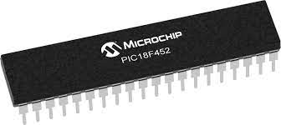

## 2. EM 18 READER

The EM-18 RFID Reader module operating at 125 kHz is an inexpensive solution for your RFID based application. The Reader module comes with an on-chip antenna and can be powered up with a 5V power supply. Power-up the module and connect the transmit pin of the module to receive pin of your microcontroller. Show your card within the reading distance and the card number is thrown at the output. Optionally the module can be configured for also a weigand output.

|  |  |
| --- | --- |
| VCC | Should be connected to positive of power source. |
| GND | Should be connected to ground. |
| BUZZ | Should be connected to BUZZER |
| NC | No Connection |
| NC | No Connection |
| SEL | SEL=1 then o/p =RS232  SEL=0then o/p=WEIGAND |
| TX | DATA is given out through TX of RS232 |
| DATA1 | WEIGAND interface DATA HIGH pin |
| DATA0 | WEIGAND interface Data Low pin |



## 3. WI-FI MODULE ESP8266

ESP8266 comes with capabilities of 2.4 GHz Wi-Fi (802.11 b/g/n, supporting WPA/WPA2),general-purpose input/output (16GPIO),Inter-Integrated Circuit (I²C) serial communication protocol, analog-to-digital conversion(10-bit ADC) Serial Peripheral Interface (SPI) serial communication protocol,I²S (Inter-IC Sound) inter faces with DMA (Direct Memory Access) (sharing pins with GPIO) ,UART (on dedicated pins ,plus a transmit-only UART can be enabled on GPIO2) ,and pulse-width modulation (PWM).It employs a 32-bit RISC CPU based on the Ten silica Xtensa L106 running at 80 MHz (over clocked to160MHz).It has a 64KB boot ROM, 64KB instruction RAM and 96 KB data RAM. External flash memory can be accessed through SPI. ESP8266 module is low cost stand alone wireless transceiver that can be used for end-point IOT developments.

ESP-01 comes with 8 pins(2GPIOpins) –PCB trace antenna.(shown In above figure)

ESP-02comeswith8pins,(3GPIOpins) –U-FL antenna connector.

ESP-03comeswith14pins,(7 GPIO pins)–Ceramic antenna.

ESP-04comeswith14pins,(7GPIO pins)–No ant.

**4. MOTOR DRIVER CIRCUIT:-**

Here in our project we are using a 12v DC motor which is Bipolar, which means that the DC motor can rotate both the sides .For this we are using a DC motor driver IC L293D.This driver IC can drive 2 DC motors. In our project we are connecting only 1 DC motor so we are connecting only the 1st pair of the DC motor.(in1 and in2 of L293D).The DC motor will be connected at OUT1 and OUT2 of L293D respectively.

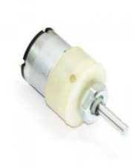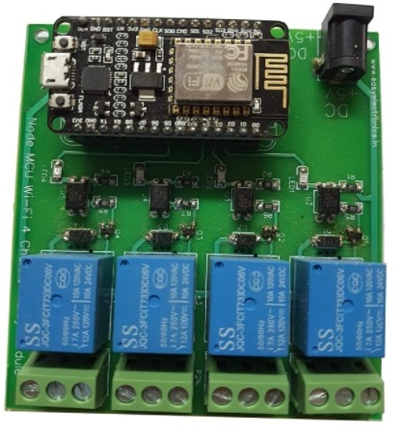

**4.4x4 matrix keypad**

This 4x4 matrix keypad has 16 built-in pushbutton contacts connected to row and column lines.  A microcontroller can scan these lines for a button-pressed state.  In the keypad library, the Propeller sets all the column lines to input, and all the row lines to input.  Then, it picks a row and sets it high.  After that, it checks the column lines one at a time.  If the column connection stays low, the button on the row has not been pressed.  If it goes high, the microcontroller knows which row (the one it set high), and which column, (the one that was**=** detected high when checked).

In a 4×4 matrix keypad, there are four rows and four columns connected to 16 push button switches. It may look like one needs 16 pins for the microcontroller to be connected to the matrix keypad, but practically 16 inputs of keypad interface are possible with the 8 pins of a microcontroller port.

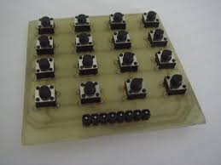

## 5. Liquid Crystal Display (LCD)

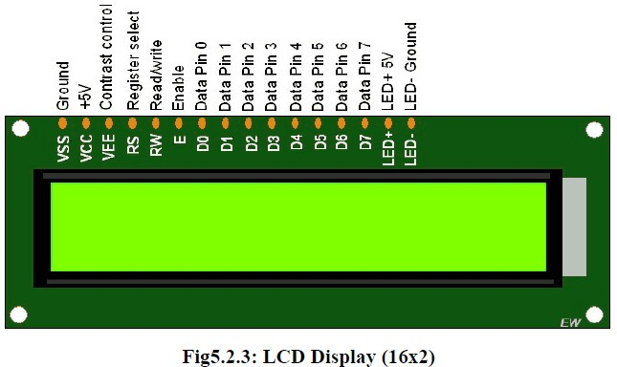LCD screen is an electronic display. This is used which displays the status of the system. A 16x2LCD display is very basic module that has 2 controller with 16pin which is very commonly used in various devices and circuits.

**6. RFID Card:-**

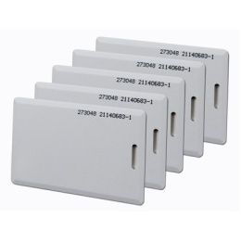Radio Frequency Identification (RFID) refers to a wireless system comprised of two components: tags and readers. The reader is a device that has one or more antennas that emit radio waves and receive signals back from the RFID tag. Tags, which use radio waves to communicate their identity and other information to nearby readers, can be passive or active. Passive RFID tags are powered by the reader and do not have a battery. Active RFID tags are powered by batteries.

**7. Temperature Sensor: LM35**

Temperature sensor is used to sensing the temperature. We have used a Temperature sensor called LM35. This temperature sensor can sense the temperature of the atmosphere around it or the temperature of any machine to which it is connected or even can give the temperature of the human body is used. So, irrespective of the application to which it is used, it gives the reading of the temperature. The LM35 series are precision integrated-circuit temperature sensors, whose output voltage is linearly proportional to the Celsius (Centigrade) temperature.

Temperature sensor is an analog sensor and gives the output into form of analog signal. This signal is feed to ADC which will convert it into digital form.

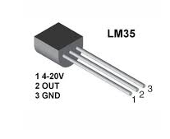

**8. LPG Gas Sensor: MQ6**

Liquefied petroleum gas, also called LPG, GPL, LP Gas, liquid petroleum gas or simply [propane](http://en.wikipedia.org/wiki/Propane) or [butane](http://en.wikipedia.org/wiki/Butane), is a [flammable](http://en.wikipedia.org/wiki/Flammable) mixture of [hydrocarbon](http://en.wikipedia.org/wiki/Hydrocarbon) gases used as a [fuel](http://en.wikipedia.org/wiki/Fuel) in [heating appliances](http://en.wikipedia.org/wiki/HVAC) and vehicles.LPG is prepared by [refining](http://en.wikipedia.org/wiki/Petroleum_refinery)[petroleum](http://en.wikipedia.org/wiki/Petroleum) or "wet" [natural gas](http://en.wikipedia.org/wiki/Natural_gas), and is almost entirely derived from [fossil fuel](http://en.wikipedia.org/wiki/Fossil_fuel) sources, being manufactured during the refining of petroleum (crude oil), or extracted from petroleum or natural gas streams as they emerge from the ground. It currently provides about 3% of all energy consumed, and burns relatively cleanly with no [soot](http://en.wikipedia.org/wiki/Soot) and very few [sulfur](http://en.wikipedia.org/wiki/Sulfur) emissions.

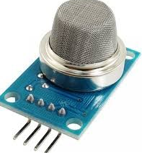

**9. Fire Sensor:**

As the sensor is flexed, the [resistance](http://wiki.bildr.org/index.php/Resistance) across the sensor increases. The resistance of the flex sensor changes when the metal pads are on the outside of the bend (text on inside of bend).Straight (inflexed) resistance: ~9000 [Ohm](http://wiki.bildr.org/index.php/Ohm) 90 degree bend resistance: ~14000 Ohm 180 degree bends resistance: ~22000 Ohm.



**10. IR Obstacle Sensor:**

Here we are connecting an IR based obstacle sensor. The 50 ohm resister is used for current limiting. The current through the LED is 5v / 50 ohm = 100 map, which is high for an LED. But to increase the range of the obstacle sensor we are using a lower range resistor (50 ohm).On the receiver side we have connected the IR receiver in reverse bias. So as soon as the light falls in the IR receiver, the anode voltage increases and when the anode voltage is more than the cathode voltage then the LED is in forward bias mode and start conducting.

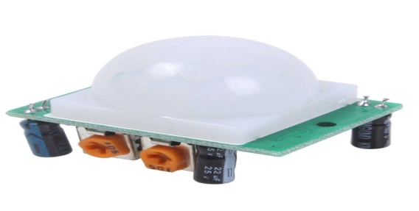

**11. Light Sensor: LDR**

Photo resistors or Light Dependent Resistors (LDR) which change resistance according to light intensity. Normally the resistance of Photo resistor (LDR) decreases with increasing intensity of light falling on it. Photomultiplier tubes containing a photocathode which emits electrons when illuminated, the electrons are then amplified by a chain of dynodes.

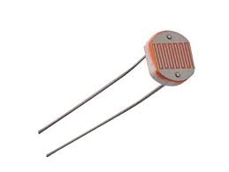

**12. WSN Protocol:**

Here we are reconfiguring the wsn using rf. here we are considering 1 master and 2 slaves structure. in this network the master will continuously scan for both the slaves. if both are in range it will gather the data directly from slaves. but if any of the slaves goes out of range of master then the master will reconfigure the network and read the data using an intermediate slave as repeater to receive the data. (co-operative communication) using nearest neighborprotocol the master will find the shortest path to destination

**5.3 GTBS protocol:**

Here we are implementing the green task based sensing. Many applications in WSN have redundant data, which means that the data does not change very fast. A task is characterized by different parameters: type of sensing, number of sensing operations, period of sensing and the intended nodes (nodes required to sense data). So sending the same data again and again results in Wastage of Network energy which in turn reduces network life time.

So, in this dissertation we will send the data whenever the sensor crosses a threshold /Set point. That means whenever a new data is present, then only the slave will send the data frame in response. This results in less number of Communication frame, which increases the Network efficiency.

Also we are designing an Android Application through which we can monitor the WSN sensor data on the android mobile. The android device is connected to the WSN via Bluetooth modem. Once the connection is established the Android App will display all the data through message on the GUI of APP.

For example, whenever the temperature will increase more than required then alert message will be send to android application.

**A) GATE TERMINAL**

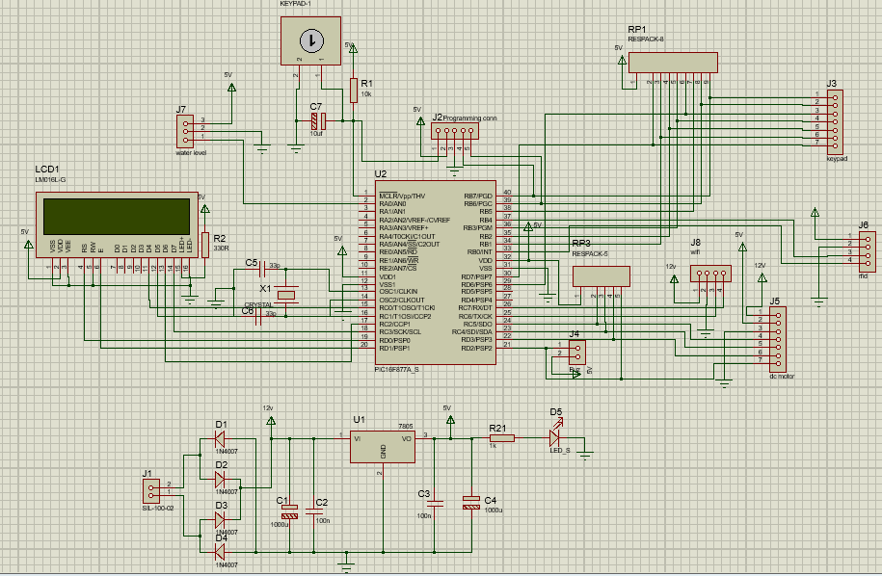

**B) FLAT TERMINAL**

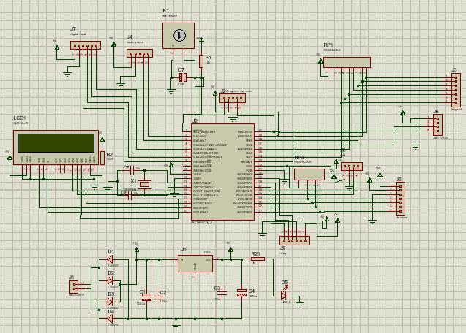

**ALGORITHM:**

**A) Algorithms for GATE Terminal**

1) Start.

2) Initialize all the ports and sensor.

3) Read the values from connected sensor& process it.

4) Convert the data as per required frame.

5) Send the frame through the VB Code.

6) Repeat the procedure from step 3.

7) Stop.

Note: Computer/Laptop must be connected to internet.

**B) Algorithms for IOT Web server**

1) Start.32

2) Run VB code

3) Access the parameter as per the designed Browser.

4) Repeat the procedure from step 3.

5) Connect the computer/ Laptop to android APP.

5) Stop.

# FLOW CHART

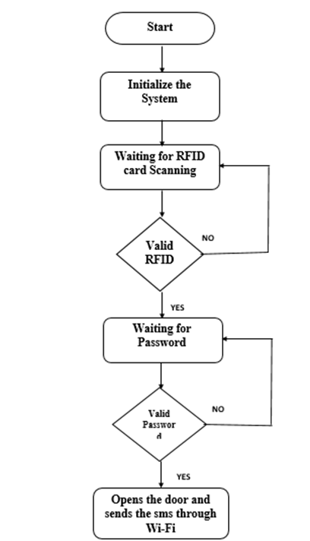

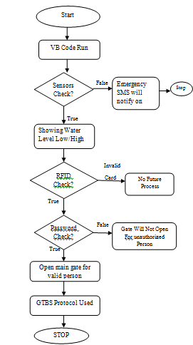

* **SOFTWARE OUTPUT**

# WhatsApp Image 2022-04-28 at 4.33.55 PM (1).jpeg

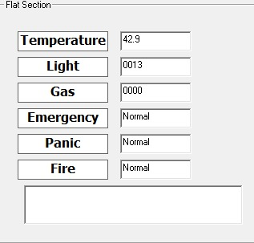

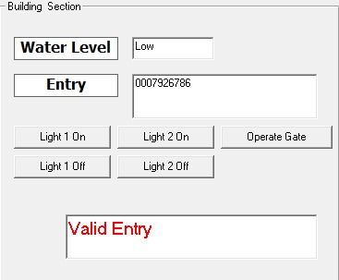

* **FLAT TERMINAL**

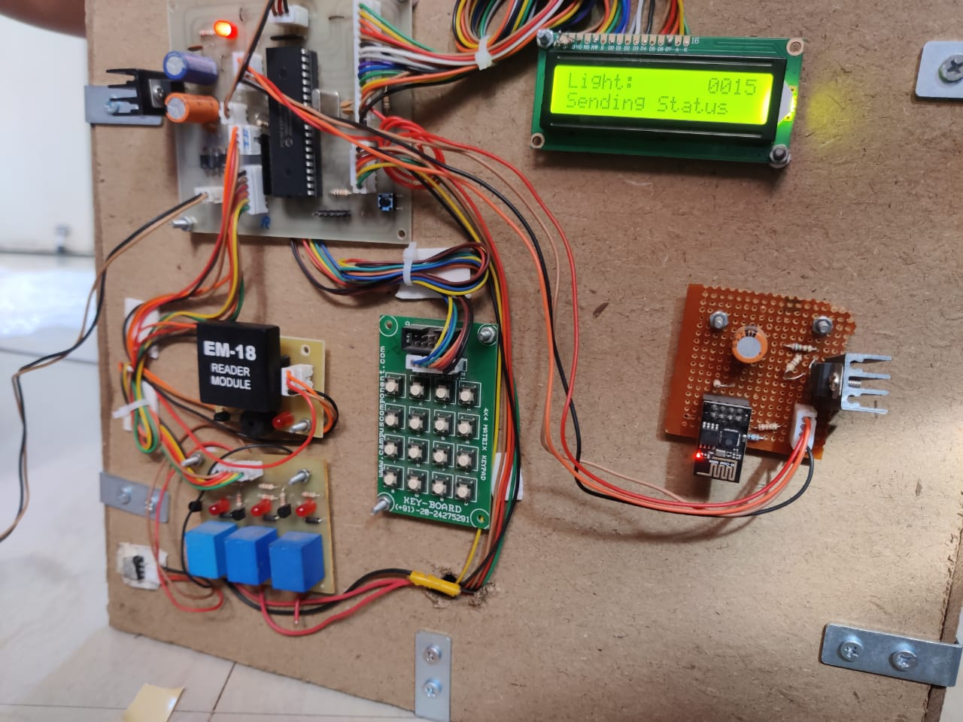

* GATE TERMINAL

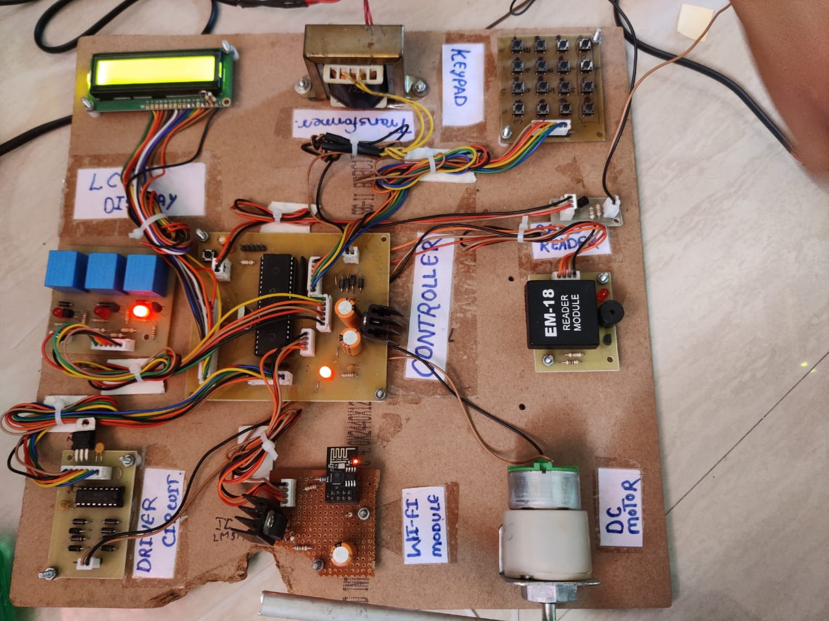

**7.1 Advantages**

* **Home security:**With IoT home automation you are less worried about home security. You can control the security of your home with your phone. If anything goes wrong, you may receive notifications on your phone and you may probably operate you lights or locks through your phone.
* **Energy efficiency and savings:**You can increase the energy efficiency by controlling your electrical fixtures through IoT. If you are unsure whether your child has left lights on before leaving, you can check and control it through your phone.
* **Convenience:**This can be considered as one of the main advantages of home automation using IoT. You have the control of all your devices connected through IoT. It makes it very convenient for you to have all the devices adjusted just through your phone. For example, if you forgot to adjust your thermostat in the morning before you left your house, you can adjust it from your office.

**7.2 Applications:**

* Environmental Monitoring
* Industrial Monitoring
* Green Agriculture
* Telemedicine
* Smart Home

**8 .FUTURESCOPE**

In this project we have discussed the importance of actuation in making buildings more energy efficient. Our research efforts have led to the development of several mechanisms for actuating the HVAC system and controlling miscellaneous plug-loads, as well as an occupancy-based policy to turn off these systems when the rooms are no longer being occupied. Many other areas of smart building research, such as modeling and prediction of building operations, can be used to augment and improve the control over a building. For example, being able to predict when occupants plan on going into their offices means that the system can pre-cool the area prior to the occupant’s arrival. Improved analysis of the sensed information can also lead to better understanding of the building processes and their inter-dependencies. Actuating one building process might have unintended effects on another, and only through a combined actuation-sensing approach can we capture this relationship. One important consideration is the economics of deploying smart building technologies. Smart building systems (such as the sensors and actuators) cost money to deploy and maintain; thus the return on the investment must be adequate for any organization to pay for the sensor systems.

While this will be different for every building, we believe that smart building systems are extremely economical and provide monetary value for buildings that choose to invest in them. Going forward, we envision a smart building system capable of holistically controlling all of the building processes. Such building processes would include not only HVAC and plug load devices, but also IT and lighting. User context can also be used to control various building systems. The thermal conditions of each room would be set automatically according to each individual’s preferences. Developing control algorithms that can optimally control all of the building processes is an ongoing technical challenge. Ultimately, the result of these technologies will be a building that not only significantly reduces energy consumption, but also improves the quality of service for every occupant. Many non-technical challenges remain however. These technologies must eventually be implemented by building designers, and thus must mature beyond research prototypes. For example, software systems must present intuitive user interfaces for building administrators and technicians who may not be fluent with information technology. Aggressive actuation to reduce energy can potentially affect occupants adversely if the algorithms are not carefully designed. Policy challenges must also be addressed - building administrators must determine how best to control the building in order to meet the multiple demands of energy conservation and occupancy comfort. While the technical challenges in developing the energy-efficient smart building are important for researchers to solve, it is vital that these other issues are considered as well.

**9. Conclusion**

* Based on surveyed study the comparison of home automation systems is presented. Microcontroller, user interface, a communication interface and their performance factor are compared.
* There are a number of do-it-yourself (DIY) platforms available that allow to create Home Automation system quickly and easily with low cost and high performance e.g. Raspberry pi, Arduino, other microcontrollers, etc. In this review explained different home automation system e.g. Web based, email based, Bluetooth-based, mobile-based, SMS based, ZigBee-based, Dual Tone Multi Frequency-based, cloud-based and Internet based. In future home automation will more smart and fast.
* It would be extended to the large scale environment such as colleges, offices and factories etc.

1. **REFERENCES**
2. 16 May 2005 **...** PIC16F877A Microcontroller in 40 DIP package. The PIC16F877A features 14.3 Kbytes Flash Memory, 368 bytes SRAM, 256 bytes EEPROM data memory **...**  
   **microcontrollers**hop.com/product _ info .Php ? Products _ id.
3. 16 Apr 2009 **...** DAILY RFID has launched 125KHz RFID proximity reader-02 designed to read a variety of low frequency passive rfid tags, with a low price at **...**  
   www.prlog.org/10218217-125khz-**rfid**-**proximity**-**reader**-for-reading-passive-**rfid**-tags.html
4. *www.seeedstudio.com/.../****WiFi****-****Serial****-Transceiver-****Module****-w-ESP8266-p-1994.html*Wireless / *WiFi Serial* Transceiver *Module* w& ESP8266. //statics3.seeedstudio.com/product/*WiFi*
5. Y. Agarwal, B. Balaji, R. Gupta, J. Lyles, M. Wei, and T. Weng. Occupancy-Driven Energy Management for Smart Building Automation. In ACM Workshop on Embedded Sensing Systems For Energy-Efficiency In Buildings, 2010.
6. Y. Agarwal, B. Balaji, R. Gupta, and T. Weng. Duty-Cycling Buildings Aggressively: The Next Frontier in HVAC Control. In IPSN, 2011.
7. Y. Agarwal, S. Savage, and R. Gupta. SleepServer: A Software-Only Approach for Reducing the Energy Consumption of PCs within Enterprise Environments. In USENIX ATC, 2010. [4] Y. Agarwal, T. Weng, and R. Gupta. The Energy Dashboard: Improving the Visibility of Energy Consump ption at a Campus-Wide Scale. In ACM BuildSys, 2009.
8. V. Erickson, M. Carreira-Perpinan, and A. Cerpa. OBSERVE: Occupancy-based system for efficient reduction of HVAC energy. In IPSN, 2011.
9. S. Gupta, M. S. Reynolds, and S. N. Patel. ElectriSense: Single-point Sensing using EMI for Electrical Event Detection and Classification in the Home. In Ubicomp, pages 139–148. ACM, 2010.

**11. WORK-PLAN**

|  |  |  |
| --- | --- | --- |
|  |  |  |
| **Sr.No** | **Project detail** | **Month** |
| 1 | Selection of Project | August |
| 2 | Datasheet study | September |
| 3 | Circuit diagram(Proteus) | October(1-15) |
| 4 | Layout Diagram(Proteus) | October(16-31) |
| 5 | Seminar Presentation | November |
| 6 | Coding and testing | November(10-20) |
| 7 | Phase I Soldering and Hardware testing | December |
| 8 | Phase I Project Report | December(10-20) |
| 9 | Phase I Demonstration | December(20-25) |
| 10 | Software Testing | February (16-26) |
| 11 | Hardware Testing | February(16-26) |
| 12 | Paper Publishing (IRJET) | March (7) |